Toys | Glue 6 | Glue 11
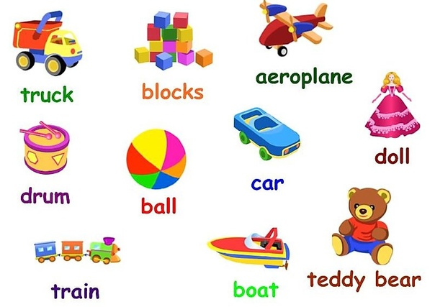  Truck |  | 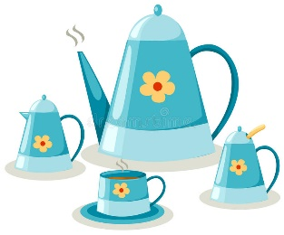
Glue 2 | Glue 7 | Glue 12
Blocks |  | 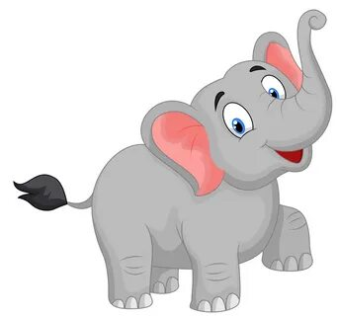
Glue 3 | Glue 8 | Glue 13
 | Car | 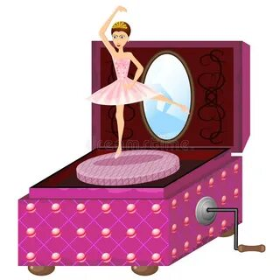
Glue 4 | Glue 9 | Glue 14
Drum | Boat | I like + игрушка  I don’t like + игрушка  My favourite toy is + игрушка
Glue 5 | Glue 10 | Glue 15
Teddy bear |  | My favoutite toy is _________

